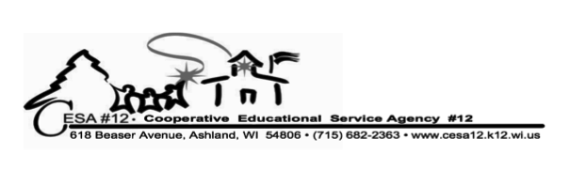
School Psychologist Shareshop Agenda
February 1, 2013
8:30am Registration
9:00am – 3:30pm Shareshop
Location: CESA 12

Reminder: Please bring or email to Deb Davis (debd@cesa12.k12.wi.us) the list of testing and assessment instruments that are available in your district(s). These will be shared with all of us so we can borrow those tests from each other that are not needed as often but are good to have. Please remember too that if you are going to borrow the tests you will have to buy the test booklets/protocols yourself.

Agenda:
9:00am – 11:00am:
Guest: Johanna Kirk, Attorney: She will be having a Q & A session for clarification on what is considered criminal activity and when police should be called into the schools to address student behavior.

11:00am – 11:15am Break

11:15am to 12:00pm
DSM-V: new Autism criteria. Laura Comer will try to join us or will provide handouts with additional information

12:00pm – 1:00pm: Lunch

1:00pm – 2:00pm:
Guests: Jerry Jorgenson from DVR and Maria Nevala from VRNA will be here for another Q & A session for us on what their vocational rehabilitation programs have to offer our students and how we can support each other.

2:00pm – 2:15pm Break

2:15pm – 2:30pm Michelle Jardine: New tool for Assessing Social Skills

2:30pm – 3:00pm CESA 12 new School Psychology evaluation tool – Deb Davis

3:00pm – 3:15pm Information on Adolescent Literacy Plan: Maija Alexandrou

3:15pm – 3:30pm Cracker Barrel

3:30pm Adjourn

Happy Superbowl, Groundhog Day, Valentine’s Day, and President’s Day

